**SECURITY ANALYSIS AND PORTFOLIO MANAGEMENT**

**EVALUATION OF MUTUAL FUNDS**

The funds taken for evaluation are-

1. Indiabulls Blue Chip Fund - Direct Plan - Dividend Option
2. IDBI DIVERSIFIED EQUITY FUND Dividend - Direct Plan
3. IDFC Multi Cap Fund-Direct Plan-Dividend
4. SBI Magnum Multicap Fund - DIRECT PLAN - Growth Option
5. Kotak Standard Multicap Fund - Dividend

And the Nav data is taken from site investing.com and their returns are calculated. We have taken 300 values for the evaluation of funds.

The market index taken is Nifty 50.

The risk free rate is taken from 10 year government bond yield.

And it is converted into per day value by using the formula-

*Daily return=(annual return/100+1)^(1/365)-1*

Risk free rate of interest is the return that an investor can earn on a riskless security. The return earned over and above the risk free rate is the risk premium that is the reward for bearing the risk. If this risk premium is divided by a measure of risk,we get the risk premium per unit of risk.

The funds may be ranked in descending order of ratio. A higher ratio indicates better performance.

The two methods of measuring the reward per unit of risk are Sharpe Ratio and Treynor Ratio.

**Sharpe Ratio**

It is reward to variability ratio.

*Sharpe ratio = [return on the portfolio - risk free rate of return] / std dev of portfolio return*.

For a portfolio that is not so well diversified, the Sharpe ratio using total risk measure would be the appropriate performance measure.

**Treynor Ratio**

It is reward to volatility ratio.

*Treynor Ratio = [Return on portfolio - risk free rate of return] / portfolio beta*.

For a fully diversified portfolio, Treynor ratio would be the appropriate measure of performance evaluation.

**Jensen Ratio**

This ratio attempts to measure the differential between the actual return earned on a portfolio and the return expected from the portfolio given its level of risk.

*Jensen alpha = excess return of fund - beta*excess return of market*.

The differential return gives an indication of the portfolio manager’s predictive ability.

The negative value of alpha indicates that the performance has been inferior.

The positive value of alpha indicates that the performance has been superior.

The zero value of alpha indicates neutral performance.

**M Squared**

M2 measure helps in measuring the returns of portfolios after adjusting the risk associated.

*M2 = risk free rate of return + excess return of fund*[std dev of market / std dev of fund].*

*RFR = 0.00019488*

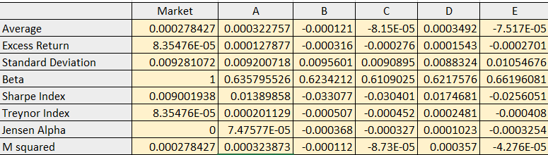

* According to Sharpe’s index, we observed that fund D is performing the best among all as it has the highest value among all fund’s Sharpe’s index.
* Similarly, comparing for Treynor index we found that here also fund D is performing the best.
* For Jensen alpha, highest value is 0.0001023 which is of fund D. Thus, here also fund D is performing the best. We also observed that funds B, C and E are performing inferior while funds A and D are performing superior.
* M-squared value for fund D is highest, thus, fund D is outperforming among all other funds.

Here, we observed that Sharpe ratio, Treynor index and M-squared values of funds B,C and E are negative which tells us that these funds are performing less than the expectations and thus should not be taken into consideration for making investments.

Ranking of funds:

Negative values are not taken into considerations thus only two funds can be considered for investment. These are: D and A, where D (SBI Magnum Multicap Fund - DIRECT PLAN - Growth Option) performed better than A (Indiabulls Blue Chip Fund - Direct Plan - Dividend Option).

|  |
| --- |
|  |